[Array 17 (2023) 100266](https://doi.org/10.1016/j.array.2022.100266)

|  |  |  |
| --- | --- | --- |
|  |  |  |
|  | Contents lists available at ScienceDirect |  |
| Array |
| journal homepage: [www.sciencedirect.com/journal/array](https://www.sciencedirect.com/journal/array) |

Automatic optimization model of transmission line based on GIS and genetic algorithm

Yuancun Qina,1, Zhaozheng Lib,1, Jieyu Dingc, Fei Zhaod,*, Ming Mengd

a *Yunnan Appraisal Center for Ecological and Environmental Engineering, Kunming 650228, China* b *Institute of International Rivers and Eco-Security, Yunnan University, Kunming 650500, China* c *School of Resources and Environmental Science, Wuhan University, Wuhan 430079, China* d *School of Earth Sciences, Yunnan University, Kunming 650500, China*

|  |  |
| --- | --- |
| A R T I C L E I N F O | A B S T R A C T |
| *Keywords:*  Transmission line  Path optimization  GIS  Genetic algorithm | At present, the planning of transmission lines mainly relies on human decision-making and lacks intelligence. This paper combines the advantages of GIS in processing spatial data with the advantages of genetic algorithm to explore the optimization method of transmission line planning. The combination of GIS and genetic algorithm can minimize the interference of human factors and quickly solve the path planning problem of transmission lines. According to the theoretical model of genetic algorithm, this study constructs the transmission line opti-mization model based on genetic algorithm, and realizes the Add-ins plug-in development of the transmission line planning model based on genetic algorithm with the help of C # language. Taking 500 kV overhead transmission line about 150 km from Jiantang Substation (starting point) in Shangri-La County to Tai’ an Substation (ending point) in Lijiang as an example, two groups of experiments are designed under the conditions of considering traffic single factor and comprehensive multi-factor respectively. It is obtained that the path optimization effect of genetic algorithm is the best under the condition of comprehensive multi-factor, which proves the rationality and superiority of the model constructed in this study. |

**1. Introduction**

Genetic algorithm is a method to search the optimal solution by simulating the natural evolution process. This algorithm converts the solving process of the problem into the process of crossover and muta-tion of chromosome genes in similar biological evolution, and can quickly obtain better optimization results when solving complex combinatorial optimization problems. Therefore, it is widely used in optimal transmission, path planning and other fields.

The current transmission line planning mainly relies on experienced professionals through map data and field survey, which requires a lot of time and material costs. GIS can obtain and analyze the data related to the region such as topography, meteorological environment and land use types, which is helpful to solve the problems such as location se-lection and path optimization [1–6]. But it lacks intelligence and needs leadership and decision-making.

The combination of GIS and genetic algorithm can minimize the interference of human factors and quickly solve the path planning

problem of transmission lines. At present, there are few studies on this problem [7–10]. It is representative that the improved ant colony al-gorithm is combined with GIS, and the distance unit is taken as the cost condition of transmission line construction, which automatically gives the reasonable planning of power grid transmission lines in short dis-tance [11]. The grid value searched by this scheme is converted from the cost index, which will change with the change of geographical and time conditions, and is uncertain, so there are shortcomings. This study will consider the geographical conditions of natural formation (such as topography, rivers and lakes, nature reserves, floating ice, meteorology, seismic belt, etc.) and social conditions of artificial formation (such as transportation, land use types, regional planning, etc.). These factors determine the difficulty of reasonable planning of power grid path and the construction cost of transmission lines. The shortest path is not necessarily the most reasonable path, and seeking the most reasonable path is the purpose of this study.

In this paper, the geographical factors and human factors that affect the transmission line planning are graded and quantified, and then

* Corresponding author.

*E-mail address:* [vwobai@163.com](mailto:vwobai@163.com) (F. Zhao).

1 Yuancun Qin a[nd Zhaozheng Li a](mailto:vwobai@163.com)s co-first authors，These authors contributed equally to this work.

<https://doi.org/10.1016/j.array.2022.100266>   
[Received 21 November 2022; Accepted 5 Dec](https://doi.org/10.1016/j.array.2022.100266)ember 2022   
Available online 7 December 2022   
2590-0056/© 2022 The Authors. Published by Elsevier Inc. This is an open access article under the CC BY license (<http://creativecommons.org/licenses/by/4.0/>).

*Y. Qin et al.*  *Array 17 (2023) 100266*

weighted according to the importance, and then transformed into the grid cost value. The genetic algorithm is used to construct the path optimization model that conforms to the characteristics of power grid transmission line planning. Combined with GIS, the Add-ins plug-in module is developed by C# and ArcObjects components on ArcGIS platform. Taking the whole process of about 150 km 500 kV trans-mission line planning from Jiantang substation in Shangri-La to Tai ’ an substation in Lijiang as an example, two groups of conditions and two algorithms of power grid line planning experiments are carried out. One group only considers the single factor cost of traffic. The other group considers the comprehensive cost after the superposition of multiple influencing factors, and uses the genetic algorithm model constructed in this paper and Dijkstra algorithm in ArcGIS to plan the transmission line path. It is concluded that the path optimized by genetic algorithm is the best when considering various factors.

**2. Transmission line optimization model based on genetic algorithm**

The optimization model is divided into two parts (Fig. 1). The first part is the establishment of the evaluation index system and the deter-mination of the weight. Then, the genetic algorithm is used to develop the Add-ins plug-in of the transmission line planning model, and the plug-in is used for actual planning.

*2.1. Evaluation index system of transmission line planning*

*2.1.1. Establishment of index system*   
 Transmission line path planning area is divided into grids. In the area, the influence factors involved are transformed into cost to repre-sent, and the influence degree of each influence factor is determined. After superposition, the cost value falls into each grid, so that all grids in the planning area have grid values.

Transmission path planning needs to be fully considered, and strive to maximize the economic benefits of the scheme. At the same time, it also needs to consider the safety and stability of the line, the conve-nience of engineering construction and maintenance and the environ-mental friendliness. Therefore, it is necessary to comprehensively consider the topographic and geological conditions, traffic, land use, disaster points, mining areas, military areas, important facilities, nature reserves, scenic spots and urban planning areas and other factors, and classify and quantify the factors and indicators affecting the line plan-ning. In this paper, 500 kV overhead transmission line planning as an example, according to the ⟪100 kV–750 kV overhead transmission line

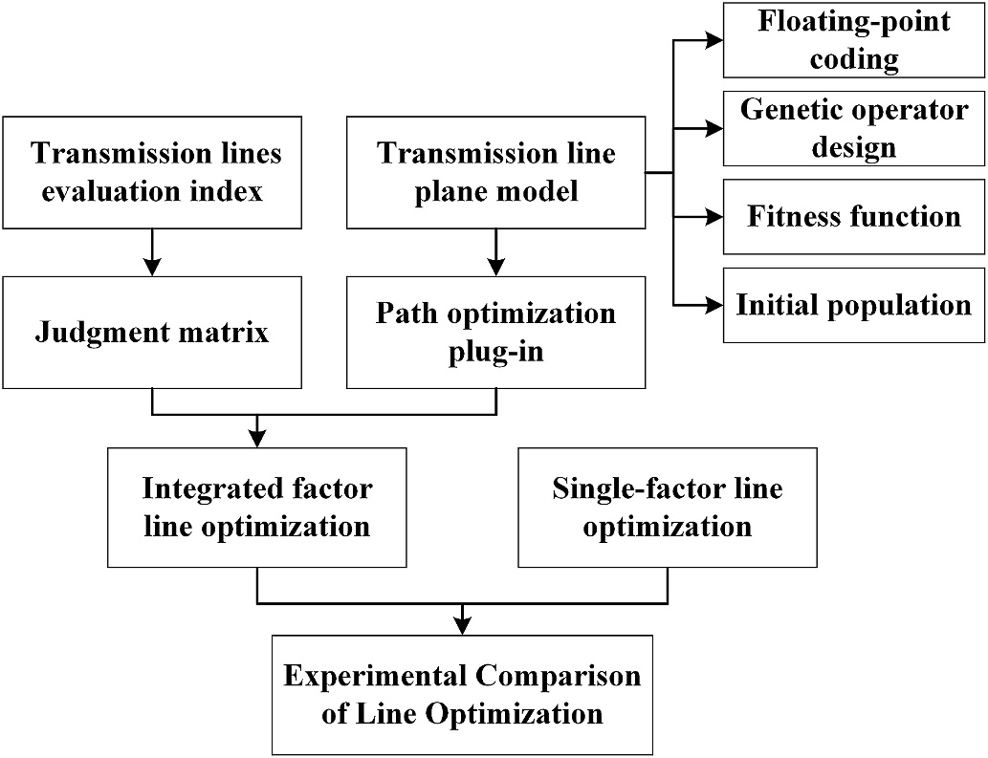

**Fig. 1.** Experiment process.

2

*Y. Qin et al.*  *Array 17 (2023) 100266*

**Table 1**   
500 kV transmission line path selection index system.

|  |  |  |  |  |  |  |  |  |
| --- | --- | --- | --- | --- | --- | --- | --- | --- |
| 500 kV transmission line selection  index system | Avoid factors  The indicator  system of non-  avoidance factor | habitation, adverse geological zone, disaster hotspots, mining area, protected areas, scenic spot and so on  influence index factor Indicator factor grading score  factor 1 2 3 4  terrain Elevation (1/ 1000–1500 m 1500m–3500 m 3500m–5000 m *>*5000 m  3)  altitude 0–20 m 20–150 m More than 150 m  difference  (1/3)  Slope (1/3) 0–5◦ 5–15◦ 15–25◦ 25–35◦ | | | | | | 5 |
| More than 35◦ water area |
| land use | land-use type | Unused  wasteland  40–3000 m | grassland, garden | woodland | residential land, cultivated land  9000–12000 m |
| Traffic | Distance  from road  Icing hazard level | 3000–6000 m | 6000–9000 m | ≤40 m or  ≥12000 m |
| Icing | Slightly ice-  covered areas (0–3 mm)  I | Lightly ice-  covered areas (3–6 mm)  II | Moderately ice  covered areas (6–9 mm)  III | Heavy icing  areas (*>*9 mm) |
| Filthy | Pollution  hazard level Seismic  intensity  grade | IV |
| seismic  intensity | ≤VI | VII | VIII | ≥IX |

Note: The score is 0 when the icing danger level is free icing areas (0 mm).

**Table 2**   
Impact factor weight judgment matrix.

|  |  |  |  |  |  |  |  |
| --- | --- | --- | --- | --- | --- | --- | --- |
| Factor | tearrain | land use | Traffic | Filthy | Icing | seismic intensity | weight |
| Terrain  land use  Traffic  Filthy  Icing  seismic intensity | 1  1/3  1  1/3  1/3  1/3 | 3  1  4  2  1/3  2 | 1  1/4  1  1/4  1/3  1/3 | 3  1/2  4  1  1  2 | 3  3  3  1  1  2 | 3  1/2  3  1/2  1/2  1 | 0.291  0.088  0.320  0.092  0.072  0.137 |

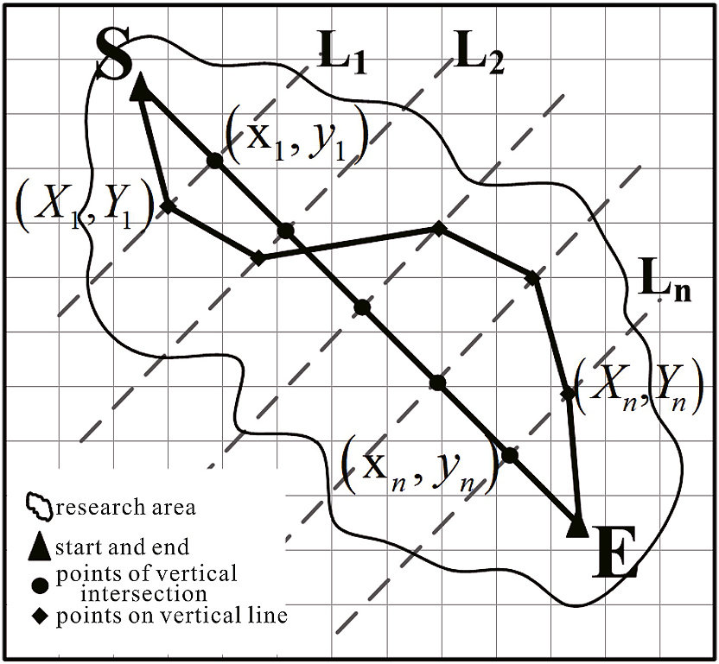

**Fig. 2.** Transmission line plane model.

the starting point (xS, yS) to the end point (xE, yE) to form an initial line.

Initial population is composed of a series of initial routes, let λ be a route composed of a set of points, P(0) is the initial population, n is the number of equally spaced points, m is the population size, then the initial population can be expressed as

|  |  |  |  |
| --- | --- | --- | --- |
| *P*(0) = (*λ*1*, λ,* ⋯*, λm*) | | | ⎫⎬⎪ |
| = | ⎧⎨⎪ | [(*xS, yS*)*,* (*x*11*, y*11)*,* (*x*21*, y*21)*,* ⋯*,* (*xn*1*, yn*1)*,* (*xE, yE*)]*,* [(*xS, yS*)*,* (*x*12*, y*12)*,* (*x*22*, y*22)*,* ⋯*,* (*xn*2*, yn*2)*,* (*xE, yE*)]*,*⋯*,*  [(*xS, yS*)*,* (*x*1m*, y*1*m*)*,* (*x*2*m, y*2*m*)*,* ⋯*,* (*xnm, ynm*)*,* (*xE, yE*)]*,* |

3

*Y. Qin et al.*  *Array 17 (2023) 100266*

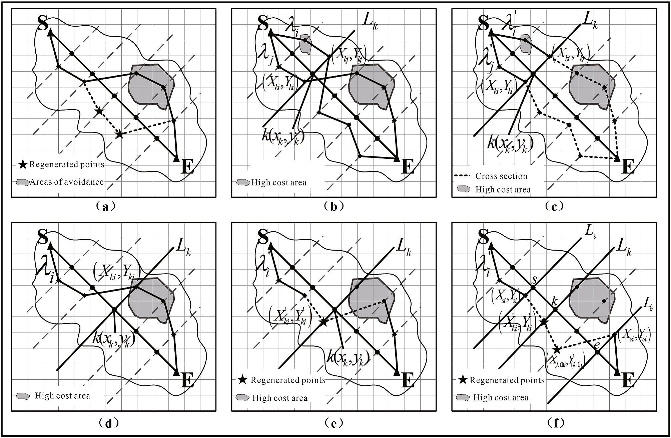

**Fig. 3.** Genetic model,(a) Initial line generation,(b) Parent individuals before crossover,(c) Subbands generated after a sigle crossover,(d) Parent individuals before

mutation,(e) Subbands generated after a sigle mutation,(f) Generate new individuals after improving mutation.

the L1, L2, …, Ln vertical lines passing through the equidistant points on SE. The optimization problem of transmission line planning is regarded as the problem of minimizing the total cost of the line, and the influence factors involved are transformed into cost to represent. The cost value is dropped into each grid, and the points along the line are selected ac-cording to a certain accuracy (the model is selected according to the grid size of the layer) to obtain the cost value of the grid corresponding to the point. The grid cost value carried by these points is the grid cost passed by the line, and the sum of points is the total cost of the line. The lower the total cost of the line, the better the target. According to the principle of the lowest total line cost, the fitness function is defined as:

F = 1 / ∑*value* ( *xg, yg* ) (2)

transmission line, D is the size of the grid, and N is the number of points In the formula, N = [l/D], g∈[1,2 … N], l is the length of λ of the

along the route. Value (xg,yg) is the raster cost value corresponding to the point taken along the road.

*2.2.4. Genetic operator design*

(1) Selection

In this paper, the selection strategy of random competition is adop-ted. A pair of individuals are randomly selected at each time, and then the two individuals are allowed to compete. The better individuals enter the next generation, and the inferior individuals are directly eliminated. This not only ensures that the better individual can be inherited, but also retains the diversity of the population, and it is easier to evolve to the optimal solution. In this model, the individual fitness value F is used for random competitive selection. The operation is to randomly select two

4

*Y. Qin et al.*  *Array 17 (2023) 100266*

tation operator design of transmission line profile is similar to binary code mutation, which regards the point set that constitutes the profile as gene, and the mutation operation is to carry out mutation on these point sets. Mutation not only increases the diversity of the population, but also evolves to produce individuals that avoid high cost zones. Fig. 3 (d)–(c) is the schematic of linear single-point variation. The idea is to randomly select a parent individual in the population and randomly generate a point k = random[1,n] with a mutation location on the individual. On the vertical line Lk that the random point k(xk,yk) passes through, a point (x’ki,y’ki) that is not in the avoidance area is randomly generated. Then change the point (xki,yki) on the original mutation site to the changed point (x’ki,y’ki). Thus the mutation operation is completed to obtain a new individual:

*λ*′*i*=

However, the mutation of a single point is often unable to generate a [ (*xS, yS*)*,* (X1*i, Y*1*i*)*,* (X2*i, Y*2*i*)…( X *ki, Y ki* ′ )…(Xn*i, Yni*)*,* (*xE, yE*) ] (5)

new individual line that completely bypasses the high-cost region, and the mutation position is very abrupt, which makes it difficult for genetic operation to search for the optimal solution. Therefore, in order to make the algorithm converge to the optimal solution better, this paper im-proves the mutation operation, as shown in Fig. 3 (f). The improved mutation operator design is to randomly generate two points S = random[k-r,k] and E = random[k,k + r] on both sides of the mutation bit k with a certain step size in the range of r (the points here are calculated as equally spaced points). If the starting and ending points S and E are in the range of the inclusion of R value, then S = random[1,k], E = random [k,k + d]; Connect the point (Xsi,Ysi) on the vertical line Ls over S to the point (X’ki,Y’ki) after mutation, A new individual λ′i is formed by connecting the constructed line point (Xei,Yei) on the vertical line Le over the point e and the mutated point (X’ki,Y’ki),

*λ*′*i*= [ (*xS, yS*)*,* (X1*i, Y*1*i*)*,* (X2*i, Y*2*i*)*,* ⋯*,* (X*si, Ysi*)*,* ( *X* (*s*+1)*i, Y* (*s*+1)*i* ′ ) *,*

⋯*,* ( The line formed in this way is relatively flat, and can better avoid the *X ki, Y ki* ′ ) *,* ⋯*,* ( *X* (*e*−1)*i, Y* (*e*−1)*i* ′ ) *,* (X*ei, Yei*)*,* ⋯*,* (X*ni, Yni*)(*xE, yE*) ] (6)

high cost area.

**3. Example experiment analysis**

*3.1. Overview of the study area*

The study area is concentrated in the northwest of Yunnan Province, which shows the terrain characteristics of Yunnan Province. The area is less suitable for planning ultra-high voltage transmission lines and has typical characteristics. The planning object is about 150 km 500 kV overhead transmission line from Jiantang substation (starting point) to Taian substation (ending point) in Shangri-La county.

*3.2. The implementation of the model algorithm*

In this study, the ArcGIS desktop application program of ESRI Cor-poration was adopted as the host program of the plug-in, combined with its ArcObjects object-oriented component library, using C# as the development language, and developed the Add-Ins plug-in of the transmission line path planning model of genetic algorithm under the Windows operating system.

*3.3. Data preprocessing*

The main work of data preprocessing includes: raster data correction, thematic electronic map data and satellite image data preparation, unified coordinate system, etc. According to Table 1, the impact factors were reclassified and assigned according to scores of 0, 1, 2, 3, 4, and 5.

Fig. 4 series is the grid layer of 500 kV transmission line path

5

*Y. Qin et al.*  *Array 17 (2023) 100266*

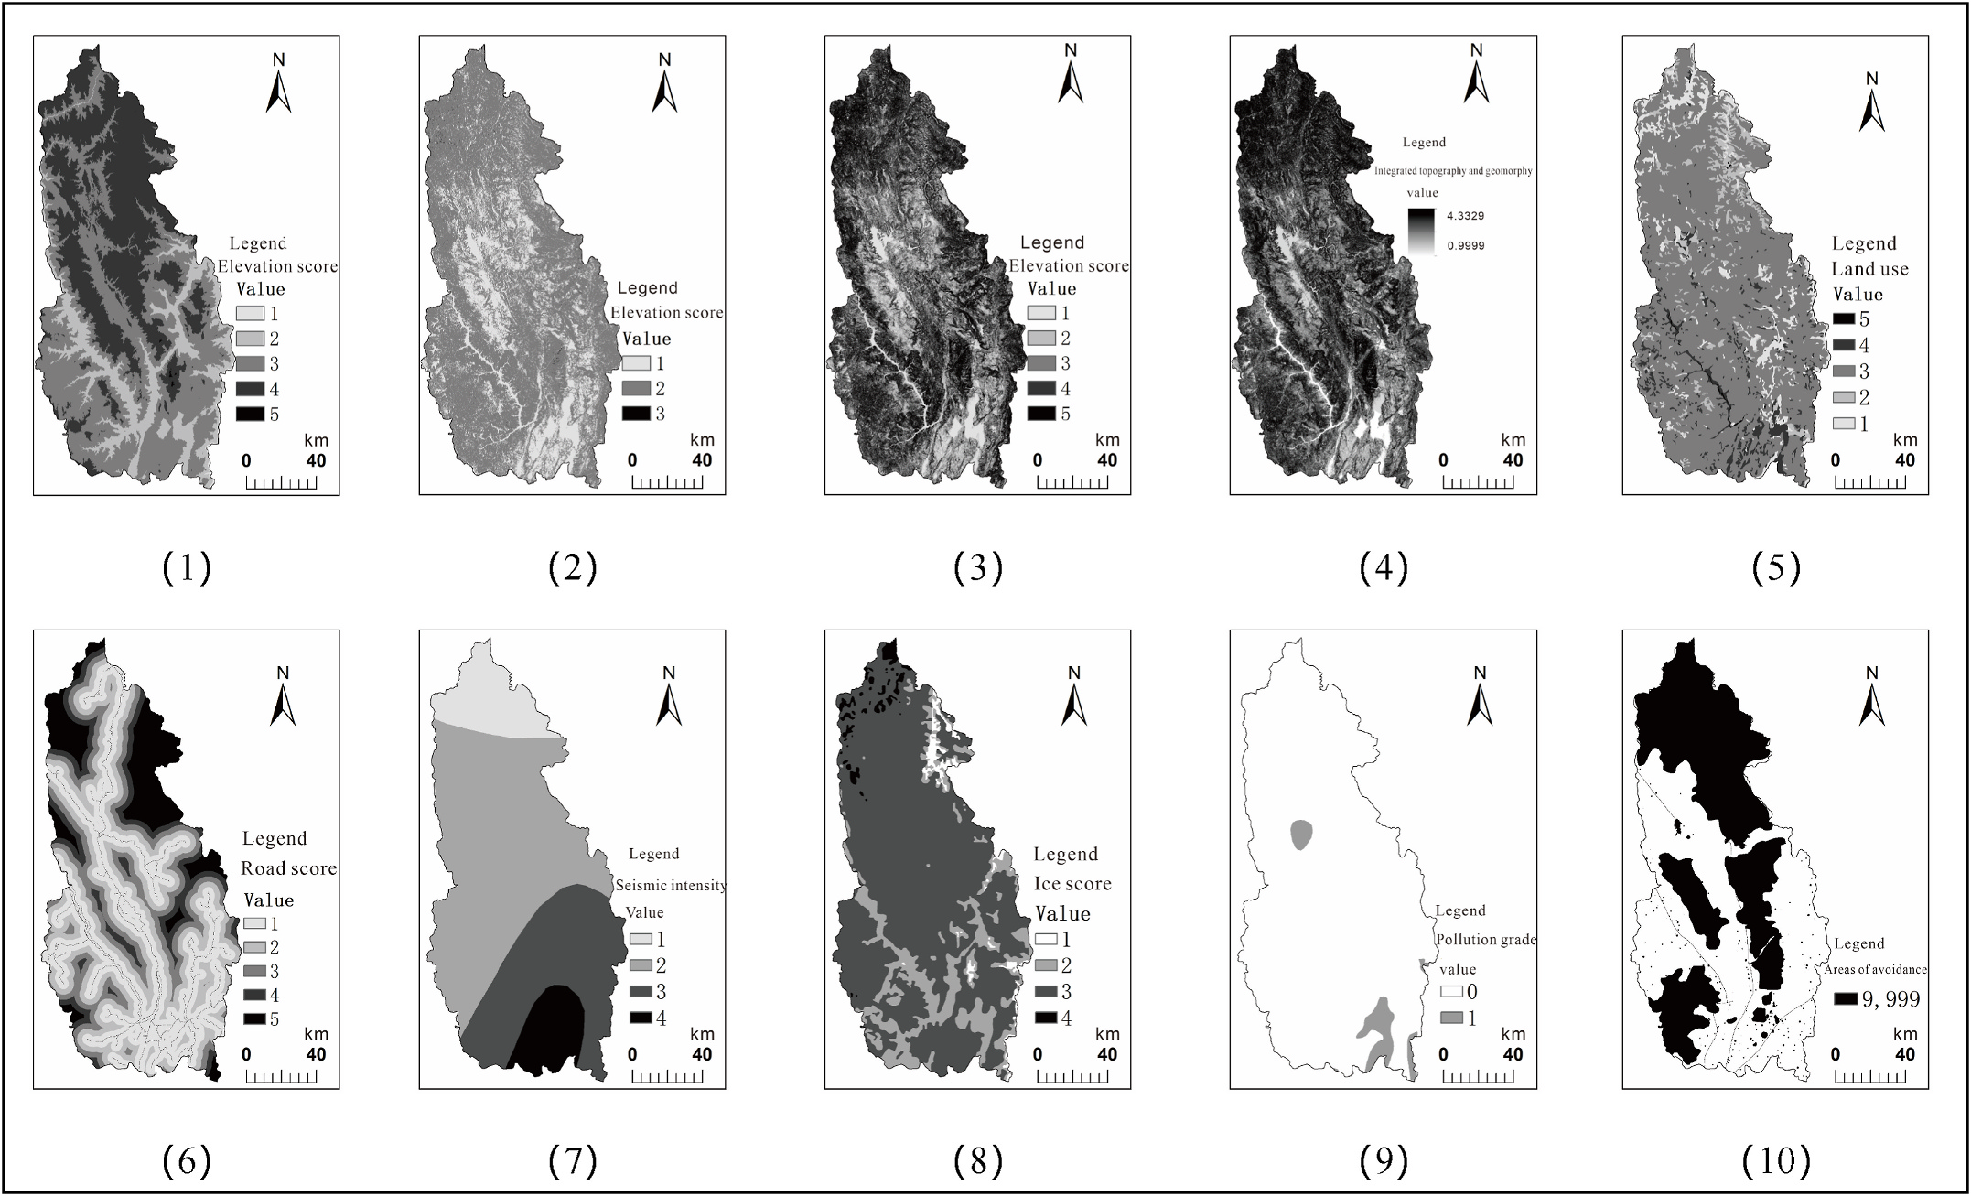

**Fig. 4.** Study area impact factor rating value map (1) Elevation value map,(2) High difference value map,(3) Slope value map,(4) Topographic features value map,(5) Landuse value map,(6) Road value map,(7) Seismic intensity value map,(8) Ice value map,(9) Pullution rating value map,(10) Avoidance area distribution map.

**Table 3**   
Parameter setting for genetic algorithm operation considering traffic factor.

|  |  |  |  |  |  |  |  |
| --- | --- | --- | --- | --- | --- | --- | --- |
| Cost grid | Corridor width (m) | Interval (m) | Number of lines | Genetic algebra | Crossover probability | Mutation probability | Mutation step (m) |
| Road score chart.Tif | 10000 | 500 | 200 | 100 | 0.5 | 0.1 | 30 |

**Table 4**   
Parameter setting for genetic algorithm operation considering integrated cost.

|  |  |  |  |  |  |  |  |
| --- | --- | --- | --- | --- | --- | --- | --- |
| Cost grid | Corridor width (m) | Interval (m) | Number of lines | Genetic algebra | Crossover probability | Mutation probability | Mutation step (m) |
| cost.Tif | 10000 | 500 | 200 | 100 | 0.5 | 0.1 | 30 |

“line comprehensive cost value” refers to the total cost value (dimen-sionless) obtained from starting point to end point by summing up the line length of each scheme in ArcGIS10.2 according to the program of “element to raster” → “raster to point” → “value extraction to point” on the comprehensive cost layer. This value is used to uniformly measure the cost value of each line in the comprehensive cost. The function of “Comprehensive cost value of the line after removing the contained collision avoidance zone grid” is to remove the large-value grid value with the collision avoidance zone grid value set as “9999′′, so as to facilitate the comparison of the comprehensive cost difference of the line without the collision avoidance zone.

According to the result table of the path scheme in Table 5, it can be seen that:

1) Comparing the total length of each path: II *<* IV *<* V *<* III *<* I, it can be seen that the path length optimized by the two algorithms is shorter than that of the built line, and the path length obtained by Scheme II is the shortest.

6

*Y. Qin et al.*  *Array 17 (2023) 100266*

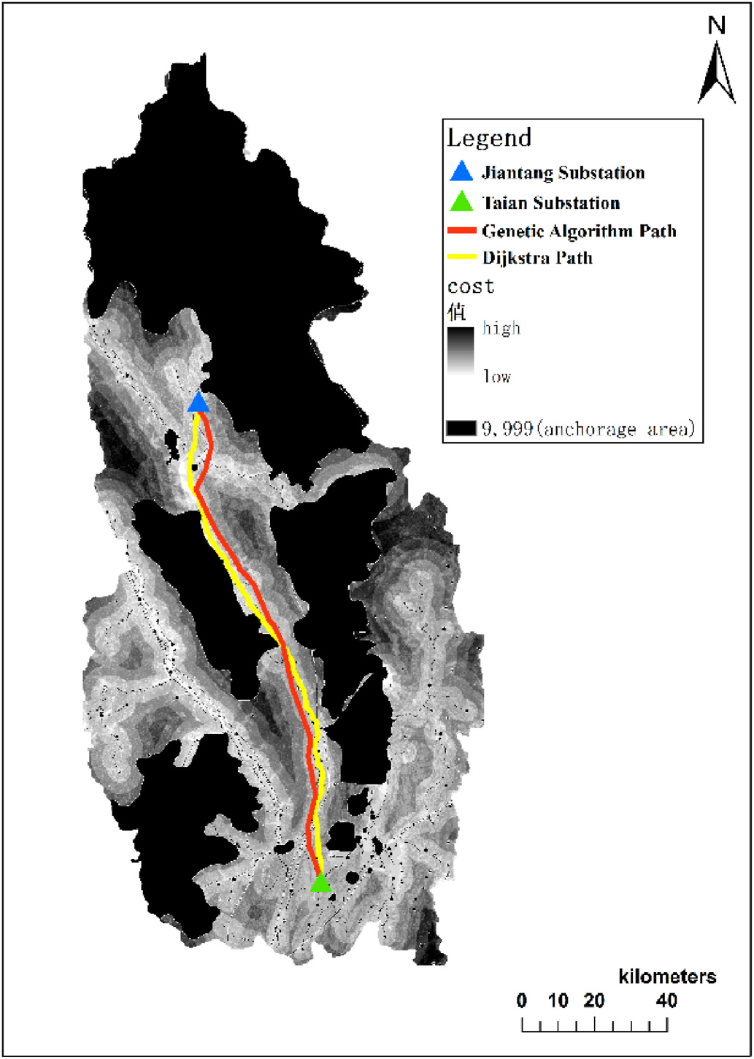

**Fig. 5.** Optimization path considering comprehensive cost.

1) There are some unreasonable places in the planning of the built lines, such as passing through more shelter zones, which will affect the surrounding environment; the path length and cost are too high, resulting in unnecessary waste.

2) When the genetic algorithm constructed in this study is used to optimize the transmission line path, it can effectively bypass the shelter areas such as residential areas, disaster points, nature re-serves, scenic spots and ecologically sensitive areas, making the power grid path more reasonable, reducing the impact on human life and ecological environment, and helping people and nature coexist harmoniously. However, the Dijkstra algorithm cannot achieve the above results.

3) The optimization of genetic algorithm can shorten the length of power grid path, reduce the comprehensive cost, improve the economy and practicability of transmission lines, and reduce un-necessary waste of human and material resources.

4) When only the single factor of traffic is considered, the results ob- tained by either genetic algorithm or Dijkstra algorithm are not ideal.

Therefore, we need to establish a comprehensive and objective evaluation system. Under the premise of synthesizing many factors, the algorithm is applied to optimize, so as to obtain the reasonable results as far as possible.

*3.5.2. Combined image analysis*

1) The overall trend of the four optimized lines is similar to that of the existing lines, and the differences are mainly concentrated in local areas, such as ①② area in Fig. 6.

7

*Y. Qin et al.*  *Array 17 (2023) 100266*

construction requirements. According to the actual situation, the river crossing point of I is reasonable.

According to the comprehensive calculation data results and the image analysis of the path, the path chosen by this experiment scheme II is the optimal one in theory, it can effectively bypass the avoidance zone, can search a path with the shortest length and can weigh the factors that have an impact on the transmission line planning, and it is relatively scientific and reasonable.

**4. Conclusion**

In order to realize automatic power grid path optimization, this study combines genetic algorithm with GIS, and designs a transmission line optimization model based on genetic algorithm by analyzing the application of GIS and artificial intelligence in the field of power grid path optimization. At the same time, the Add-ins plug-in development of transmission line planning model based on genetic algorithm is realized by C # language. Taking 500 kV overhead transmission line about 150 km from Jiantang Substation (starting point) to Tai ’an Substation (ending point) in Shangri-La County as the planning object, the model is verified and discussed, and the rationality and superiority of the model are finally proved.

Due to the lack of knowledge about power grid erection, there may be omissions in considering the cost problem, so the evaluation index system of transmission lines can be further discussed. At the same time, because the analytic hierarchy process depends on expert opinions to determine the weight, the next step can refer to the idea of multi- objective genetic algorithm to optimize, reduce the influence of human subjectivity on the experiment, improve intelligence.

Finally, the following results are obtained:

(1) The transmission line optimization model based on genetic al-gorithm is designed. According to the structural characteristics of genetic algorithm, the floating-point coding method is used to design the appropriate genetic operator, and the planar linear model of transmission line is constructed after considering the generation mode of initial population and the fitness function.

Develop the Add-ins plug-in. With the help of C # language, a plug-in that can realize the optimization function of genetic al-gorithm is developed.

(2) The superiority of genetic algorithm in power grid path optimi-zation is discussed with examples. Taking 500 kV overhead transmission line about 150 km from Jiantang Substation (start-ing point) in Shangri-La County to Tai’ an Substation (ending point) in Lijiang as an example, two groups of experiments are designed under the conditions of considering traffic single factor and comprehensive multi-factor respectively. It is obtained that the path optimization effect of genetic algorithm is the best under the condition of comprehensive multi-factor, which proves the rationality and superiority of the model constructed in this study.

**Declaration of competing interest**

The authors declare that they have no known competing financial interests or personal relationships that could have appeared to influence the work reported in this paper.

**Data availability**

Data will be made available on request.

**Acknowledgements**

This work was supported by the National Natural Science Foundation of China [grant number 51467022], the Yunnan Fundamental Research

8

|  |  |  |  |
| --- | --- | --- | --- |
| *Y. Qin et al.* | JieYu Ding received a B.S. degree from Yunnan University,  Kunming, China, in 2020. She is currently pursuing an M.S.  degree in cartography and geography information system at  Wuhan University, Wuhan, China. Her research interests  include geographic information visualization. Email:  [jadeding@whu.edu.cn](mailto:jadeding@whu.edu.cn) |  | *Array 17 (2023) 100266* |
|  | Ming Meng is currently a professor in the School of Earth Sci-ences, Yunnan University, Kunming, China. His main research interests include spatial information visualization, intelligent geographic information system and intelligent map. E-mail: [mengming586@sina.com](mailto:mengming586@sina.com) |
|  | Fei Zhao received a Ph.D. from Wuhan University, Wuhan, China, in 2012. He is currently an associate professor in the School of Earth Sciences, Yunnan University, Kunming, China. His main research interests include cartography and spatial analysis. Email: [vwobai@163.com](mailto:vwobai@163.com) |

9